**Name: _______________________________________ Partner: ________________________________**

**Python Activity 6: IF-ELSE Statements**

|  |
| --- |
| **Learning Objectives**  Students will be able to:  *Content:*   * Implement the Python syntax of an if/else statement * Determine good test data for programs that include if/else statements   *Process:*   * Write code that includes if statements and if/else statements   **Prior Knowledge**   * Python concepts from Activities 1-6 |

|  |
| --- |
| **IF Statement – Python Program** |

1. What is the output of the program listed above? What would the program print if the value stored in the variable of **grade** was 90? ____1st program output is “Excellent”your variable (grade) meets the if requirements; and it does not print anything else if the variable is changed to say 90 (as it has nothing to tell it what to do if it is lower) __________________________________________________

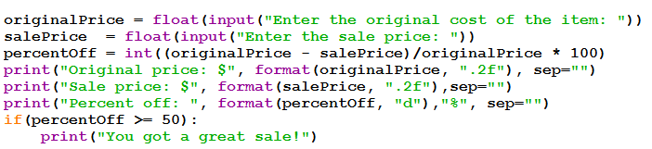2. Enter and execute the following code. Use various values for the original cost and the sale price.

Explain what the following lines of code do. Each line appears in the program above.

a. originalPrice = float(input("Enter the original cost of the item: "))

___________Gives the variable (originalPrice) a value that asks for an input from the user; stated as a float rather than an integer.___________________________________________

b. percentOff = int((originalPrice - salePrice)/originalPrice * 100)

___________This one asks to give the difference these two variables above, divided by the first variable multiplied by 100: as in integer format._____________

c. print("Original price: $", format(originalPrice,".2f"), sep="")

___________This prints the output of the users input, formatted to show only 2 decimals (proper US currency), and to remove as much spaces as possible. __________________________________

d. print("Percent off: ", format(percentOff, "d"),"%", sep="")

_________This prints the users input in a whole number format with a percentage after the input. ____________________________

e. if percentOff >= 50:

print("You got a great sale!")

**________This states that if the percent off was greater than or equal to 50, that it should exclaim that you got a great deal!_____________________________**

3. Revise the program in #2. If the percent off is 50% or more print “Congratulations!” in addition to what is already printed. Use a second print statement to do this. Rewrite the code for the last part of the program that includes the **if** statement.

______________________________________________________________________________

______________________________________________________________________________

______________________________________________________________________________

4. Revise the program in #2 so that it prints “Done!” when the program is complete – no matter what the percent off is. How does the placement of this line of code differ from the placement of the code created for #3? __________________You can simply say “else: print(“Done!”) as if the first “if” statements are fulfilled under their specifics it will simple always tell the user when it is finished.________________

|  |
| --- |
| **Python Program** |
|  |

5. Enter and execute the Python program above.

a. Test the program at least three times. List the three test data you used and the corresponding output. Be sure you test each part of the condition. Explain why the data you chose were the best data to use to thoroughly test for the program.

250, 115, and 212 were the best to test this program as it hits else statement for the second input, the if statement is then tested with both the greater than and equal to aspects.

b. Now add another print statement to the Python program above so that it prints “That’s really hot!” when the water is 212 degrees or hotter. Rewrite the if/else below with this statement included.

_______________________________if temperature >= 212: print(“Water is boiling”) if temperature > 212: print(“That’s really hot!”) else: print(“The water is not boiling.”)

________________________________________________________________________

________________________________________________________________________

6. Suppose you want to determine if a student is ready to graduate. The three criteria for graduation are that the student has earned at least 120 credits, their major GPA is at least 2.0 and their general GPA is also at least 2.0.

Which Boolean expression would be the correct test for Python code?

a. numCredits >= 120 or majorGPA >= 2.0 or overallGPA >= 2.0

b. numCredits > 120 and majorGPA > 2.0 or overallGPA > 2.0

c. numCredits > 119 and majorGPA >= 2.0 and overallGPA >= 2.0

d. numCredits >= 120 and majorGPA >= 2.0 and overallGPA >= 2.0

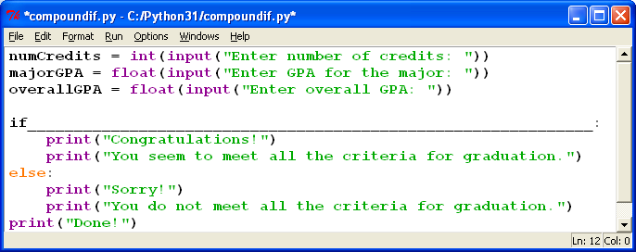

**Missing Boolean expression**

7. Enter and execute the program in #6. Include your choice for the correct Boolean expression. Create several sample data sets to test 10 different possibilities for the Boolean expression (There are 27 different combinations of possibilities). List the data you used to test these possibilities for the expression. Each set of sample data should test a different combination of possibilities.

|  |  |  |  |  |
| --- | --- | --- | --- | --- |
| **Data Set** | **numCredits** | **majorGPA** | **overallGPA** | **Expression Result (True or False)** |
| 1 | 115 | 3.5 | 3.86 | True |
| 2 | 120 | 2.5 | 2.5 | True |
| 3 | 120 | 3.8 | 4.0 | True |
| 4 | 110 | 1.9 | 1.9 | False |
| 5 | 90 | 4.0 | 4.0 | True? (Shouldn’t be) |
| 6 |  |  |  |  |
| 7 |  |  |  |  |
| 8 |  |  |  |  |
| 9 |  |  |  |  |
| 10 |  |  |  |  |

**Application Questions: Use the Python Interpreter to check your work**

1. Write the code for an **if** statement that adds 5 to the variable **num1** if the value stored in the variable **testA** equals 25. Otherwise subtract 5 from **num1.**

______________________________________________________________________________

______________________________________________________________________________

______________________________________________________________________________

2. Write a Python program that prompts the user for a word. If the word comes between the words **apple** and **pear** alphabetically, print a message that tells the user that the word is valid, otherwise, tell the user the word is out of range.

______________________________________________________________________________

______________________________________________________________________________

______________________________________________________________________________

______________________________________________________________________________

______________________________________________________________________________

3. Write a Python program that prompts the user for the cost of two items to be purchased. Then prompt the user for payment. If the amount entered is less than the total cost of the two items, print a message that states how much is still owed. Otherwise, print a thank you message and state how much change will be given.

______________________________________________________________________________

______________________________________________________________________________

______________________________________________________________________________

______________________________________________________________________________

______________________________________________________________________________

______________________________________________________________________________

______________________________________________________________________________

______________________________________________________________________________

4. Write a Python program that prompts the user for a multiple of 5 between 1 and 100. Print a message telling the user whether the number they entered is valid.

______________________________________________________________________________

______________________________________________________________________________

______________________________________________________________________________

______________________________________________________________________________

______________________________________________________________________________